Clearing House
# Source: AI Source: Provided by: [Data Path: Persons Table -> ID Column: 1, Name_En Column: Motasem Essam] -> From: [ChatGPT] on [1/21/2026]
A clearing house is a key intermediary in payment systems that processes, validates, and matches payment instructions between financial institutions before final settlement. It ensures that all parties agree on the transaction details and prepares transactions to be settled accurately and securely, often in batches.

🧠 Simple Definition
# Source: AI Source: Provided by: [Data Path: Persons Table -> ID Column: 1, Name_En Column: Motasem Essam] -> From: [ChatGPT] on [1/21/2026]
A clearing house is an institution that facilitates the exchange of payment instructions between banks or payment providers, checks for consistency, and prepares them for final settlement at the central bank or another settlement entity.

🔄 Clearing vs Settlement
# Source: AI Source: Provided by: [Data Path: Persons Table -> ID Column: 1, Name_En Column: Motasem Essam] -> From: [ChatGPT] on [1/21/2026]
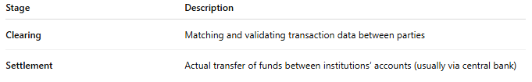

Stage | Description
Clearing | Matching and validating transaction data between parties
Settlement | Actual transfer of funds between institutions’ accounts (usually via central bank)

🎯 Core Functions of a Clearing House
# Source: AI Source: Provided by: [Data Path: Persons Table -> ID Column: 1, Name_En Column: Motasem Essam] -> From: [ChatGPT] on [1/21/2026]
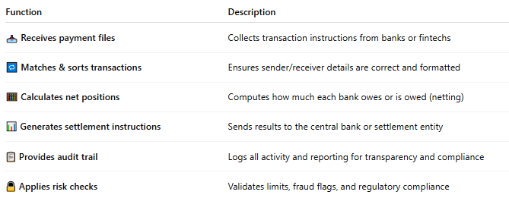

Function | Description
📥 Receives payment files | Collects transaction instructions from banks or fintechs
🔁 Matches & sorts transactions | Ensures sender/receiver details are correct and formatted
🧮 Calculates net positions | Computes how much each bank owes or is owed (netting)
📊 Generates settlement instructions | Sends results to the central bank or settlement entity
📋 Provides audit trail | Logs all activity and reporting for transparency and compliance
🔒 Applies risk checks | Validates limits, fraud flags, and regulatory compliance

🏦 Types of Clearing Houses
# Source: AI Source: Provided by: [Data Path: Persons Table -> ID Column: 1, Name_En Column: Motasem Essam] -> From: [ChatGPT] on [1/21/2026]
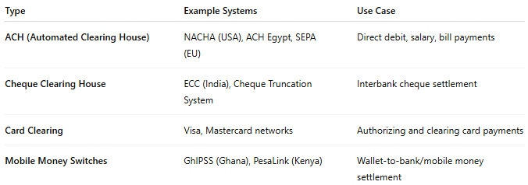

Type | Example Systems | Use Case
ACH (Automated Clearing House) | NACHA (USA), ACH Egypt, SEPA (EU) | Direct debit, salary, bill payments
Cheque Clearing House | ECC (India), Cheque Truncation System | Interbank cheque settlement
Card Clearing | Visa, Mastercard networks | Authorizing and clearing card payments
Mobile Money Switches | GhIPSS (Ghana), PesaLink (Kenya) | Wallet-to-bank/mobile money settlement

🌍 Examples of National Clearing Houses
# Source: AI Source: Provided by: [Data Path: Persons Table -> ID Column: 1, Name_En Column: Motasem Essam] -> From: [ChatGPT] on [1/21/2026]
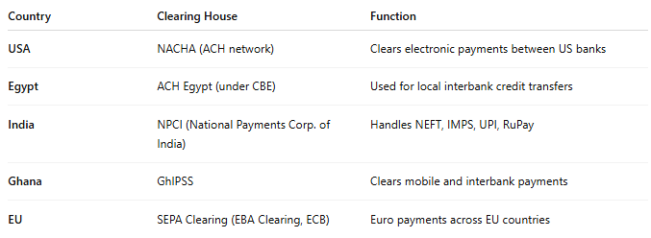

Country | Clearing House | Function
USA | NACHA (ACH network) | Clears electronic payments between US banks
Egypt | ACH Egypt (under CBE) | Used for local interbank credit transfers
India | NPCI (National Payments Corp. of India) | Handles NEFT, IMPS, UPI, RuPay
Ghana | GhIPSS | Clears mobile and interbank payments
EU | SEPA Clearing (EBA Clearing, ECB) | Euro payments across EU countries

✅ Why Clearing Houses Matter
# Source: AI Source: Provided by: [Data Path: Persons Table -> ID Column: 1, Name_En Column: Motasem Essam] -> From: [ChatGPT] on [1/21/2026]
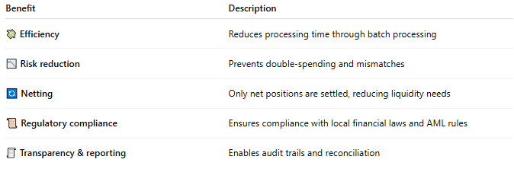

Benefit | Description
💸 Efficiency | Reduces processing time through batch processing
📉 Risk reduction | Prevents double-spending and mismatches
🔄 Netting | Only net positions are settled, reducing liquidity needs
📜 Regulatory compliance | Ensures compliance with local financial laws and AML rules
🧾 Transparency & reporting | Enables audit trails and reconciliation

🔐 Example Flow: ACH Payment Clearing
# Source: AI Source: Provided by: [Data Path: Persons Table -> ID Column: 1, Name_En Column: Motasem Essam] -> From: [ChatGPT] on [1/21/2026]
- Bank A sends a file of salary payments to the clearing house.
- The clearing house:
  - Validates formats and balances
  - Matches recipient accounts across banks
  - Calculates how much each bank must pay/receive
- Settlement instructions are sent to the central bank (e.g., CBE).
- Funds are moved between banks in real-time or next-day.

🧠 Summary
# Source: AI Source: Provided by: [Data Path: Persons Table -> ID Column: 1, Name_En Column: Motasem Essam] -> From: [ChatGPT] on [1/21/2026]
Role | Description
What it does | Validates and prepares transactions for settlement
Who uses it | Banks, fintechs, mobile money providers, card networks
Final settlement happens at | Central Bank or designated settlement entity
Common types | ACH, card clearing, cheque clearing, mobile money switches
Importance | Ensures accurate, safe, and efficient interbank payments

Would you like a flowchart of clearing vs settlement, showing where the clearing house fits between banks and the central bank?

